Adventist University of Central Africa

GRADCONNECT HUB

CASE STUDY: ADVENTIST UNIVERSITY OF CENTRAL AFRICA

(AUCA)

A topic for a final year project, submitted to the faculty of Information Technology

for approval

by

MAHORO Raphaela, #24073

Majoring in

Software Engineering

June, 2024

**PART I**

**AS IS PROCESS MODEL**

**Introduction**

Established in 1984, the Adventist University of Central Africa (AUCA), affectionately known as MUDENDE, epitomizes excellence in higher education in Rwanda. With campuses in Masoro, Gishushu, and Ngoma, AUCA is committed to nurturing holistic growth, where intellectual, spiritual, and social development converge. Upholding values of love, faith, excellence, and integrity, AUCA stands as a testament to its unwavering dedication to Christ-centered holistic education.

AUCA carries out several key responsibilities, including: Teaching and Learning through innovative, relevant, and market-driven academic programs at both undergraduate and graduate levels; Research by creating a conducive environment to undertake quality and relevant research that impacts communities; Consultancy and Community Outreach by participating in community programs and activities as part of its Corporate Social Responsibility. Of these, this study focuses on Teaching and Learning, exploring AUCA's commitment to linking students to job opportunities by enhancing current communication channels, bridging the gap between academia and the job market, and solidifying AUCA's role in preparing individuals for service in both their professional and personal lives.

The absence of structured communication channels at AUCA poses a significant challenge, especially in facilitating job opportunities for students and graduates. Relying heavily on informal networking leads to missed connections and limited career guidance, resulting in unemployment, lack of professional knowledge, and reduced confidence in navigating the job market. Addressing this issue is essential to fulfilling AUCA's mission of linking individuals to job opportunities and preparing them for meaningful service in both their professional and personal lives.

To put it briefly, bridging the gap between AUCA students, graduates, and potential employers is imperative for the institution's continued success in fulfilling its mission. By addressing the challenges associated with unstructured job opportunity transfer, AUCA can enhance its role in preparing individuals for meaningful service in both their professional and personal lives.

**Modeling the Current Job Opportunities Transfer Process**

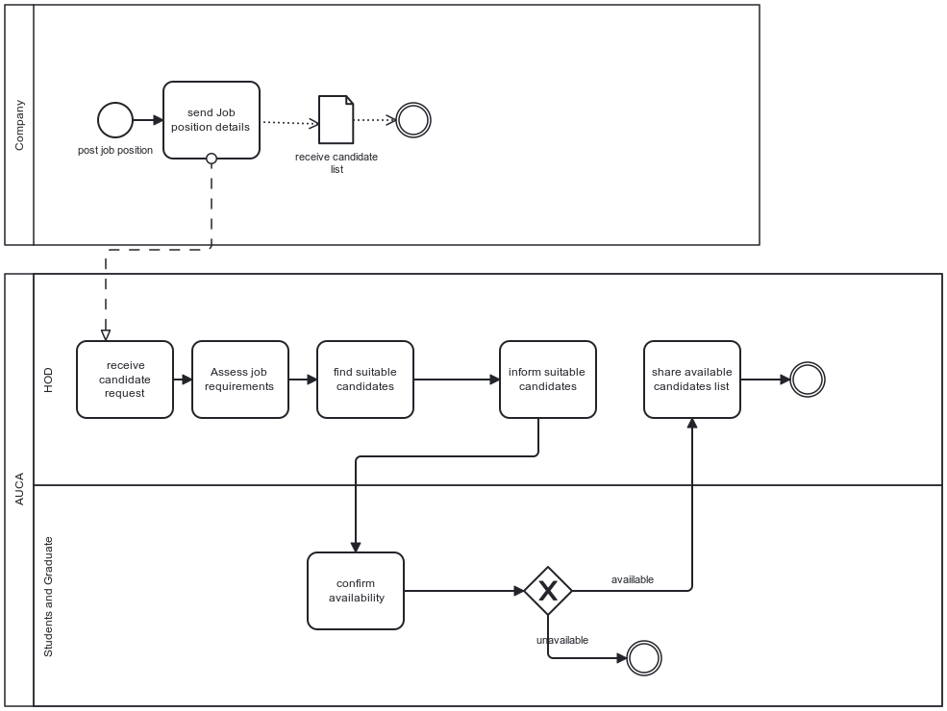

Figure 1: Modeling the Current Job Opportunities Transfer Process

**1st Step:** The company contacts AUCA seeking candidates for their vacant job positions.

**2nd Step:** The Head of Studies receive the candidates request.

**3rd Step:** The Head of Studies assesses the job requirements and identifies suitable candidates.

**4th Step:** The Head of Studies informs the selected students and graduates about the job opportunity.

**5th Step:** Interested students and graduates confirm their intention to apply for the position.

**6th Step:** The Head of Studies shares the list of confirmed applicants with the company.

**PART II**

**PROBLEMS WITH THE CURRENT SYSTEM**

**Performance**

**Throughput**

* Job request from students and Job posts are processed each at a time by the Head of Studies. Given the high volume of job requests and posts, this method cannot keep up with the demand, leading to missed opportunities for timely job placements.

**Response Time**

* The system relies on the availability of the Head of Department, both employers and students face significant delays. The Head of Department can only respond to requests when he/she is available, which leads to prolonged wait times and reduced efficiency. This dependency creates bottlenecks, as the response time is contingent upon the Head of Studies' schedule, making the system less responsive to immediate needs and opportunities. Consequently, students may miss timely job openings and employers may not get prompt access to potential candidates, thereby hindering the overall effectiveness of linking academia with the job market.

**Information**

**Input:**

* There is no standardized job posting template, leading to incomplete details regarding job requirements and compensation. This inconsistency hinders students' ability to make informed decisions about potential opportunities.
* The absence of standardized templates and platforms for students to effectively showcase their skills and talents limits their visibility to potential employers. This lack of structured presentation diminishes students' chances of securing suitable employment opportunities aligned with their qualifications and aspirations.

**Storage:**

* Access and availability of information is limited to a few people.
* The decentralized nature of information storage makes it difficult to perform analytics that could efficiently match suitable candidates to employers.

**Output:**

* Without a formalized mechanism to enhance communication and networking, AUCA struggles to provide a detailed report on the effectiveness of its efforts in linking students to job opportunities. Key metrics such as employment rates post-graduation, alumni success stories, and industry partnerships remain under-documented and inadequately visualized. As a result, potential employers may not have sufficient visibility or confidence in AUCA as a source for talented individuals, thereby limiting opportunities for students and graduates to connect with relevant job opportunities.

**Economics**

* The current reliance on informal networking and personal connections for job placement results in hidden costs at AUCA. Without a structured communication system, the institution expends substantial resources on outreach efforts, such as airtime, to connect employers with students and graduates. These expenses often exceed planned communication budgets, exacerbated by the lack of tools to measure or estimate communication costs based on demand.

**Control**

* Security is a significant concern in the current system, especially regarding the confidentiality and integrity of exchanged information. Without robust security measures, there's a risk of unauthorized access to personal and professional data, potentially compromising privacy and exposing individuals to identity theft or fraud.

**Efficiency**

* The Head of Department processes job requests one at a time, leading to delays.
* Information relay from the Head of Department to students is often done by word of mouth, which leads to loss of information

**Service**

* The informal nature of the job placement process at AUCA results in a lack of transparency and equal opportunity. Job opportunities primarily circulate through personal networks known to the Head of Departments, excluding those outside this circle from timely access to information. This limits the visibility of available opportunities to a select few and creates an environment where students and graduates who are not personally connected may miss out on potential career advancements.